**NATIONAL INSTUTUTE OF TECHNOLOGY, KURUKSHETRA**

**Department of Computer Engineering**

**Submissions**

**------------------------- - - - -------------------------------------**

|  |  |
| --- | --- |
| **Programme** | : B.Tech (Information Technology) |
| **Semester/ Year** | : 4rth /2nd |
| **Course Name** | : SW Verification and Validation |
| **Course Cod** | : ITPC-24 |
| **Student’s Roll No** | :11710544 |
| **Student’s Name** | :Gaurav Yadav |
| **Section** | : IT-3 |
| **Lab Instructor** | : Mr. Vikram Singh |
| **Course Coordinator** | : |

**Academic Session:** EVEN Sem. (2018-19)

**Experiment No. 02**

**Focus area:** Understand the needs of Verification

1. Choose an appropriate Verifier tool and methods,  for each phase in SDLC,  for the below-given problem description :
2. “*An automated Ticket issuing system ,issue train tickets.*
3. *1.User select their source , destination and input their credit card no and personal ID number.*
4. *2.When user presses start button a menu display of potential destination is activated.*
5. *3.Once a destination has been selected users are requested to input their credit card information.*
6. *4.User is requested to enter a personal ID number.*
7. *5.Credit card is validated and the ticket is issued.*
8. ”

**Submission Details:**

1. **Business Analysis phase:** The appropriate verifier is business process network, as shown in below figure.

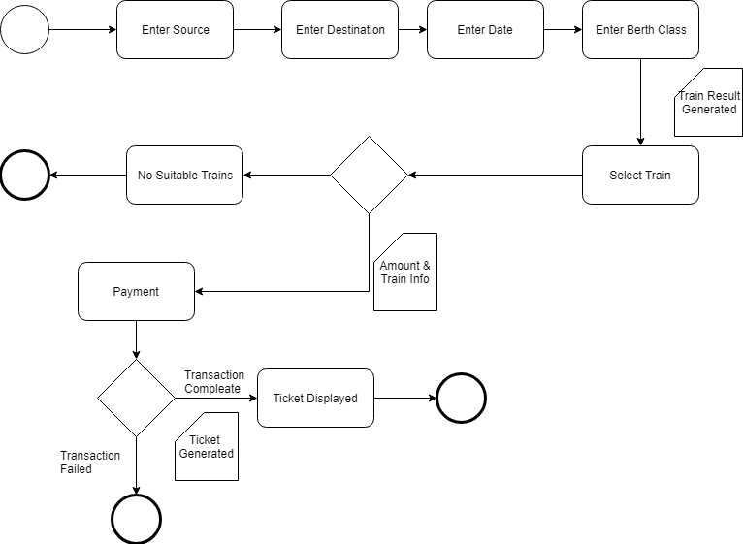

**Figure 1:**

1. **Requirement Definition phase:** The appropriate verifier is business process network, as shown in below figure.

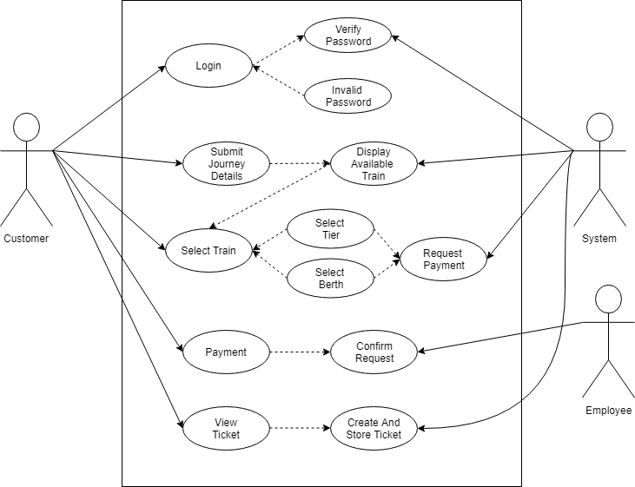

**Figure 2:**

1. **Implementation phase** The appropriate verifier is business process network, as shown in below figure.



**Figure 4:**

**Testing phase:** The appropriate verifier is business process network, as shown in below figure. 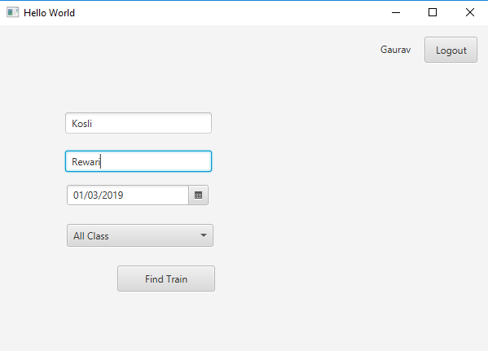

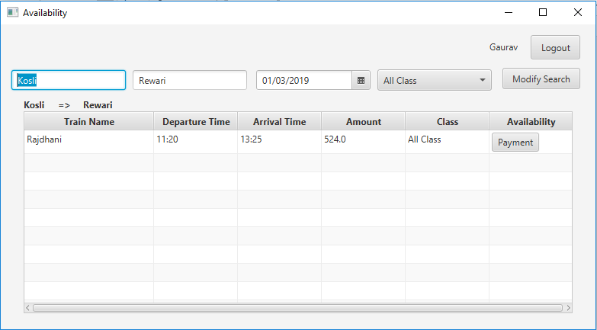 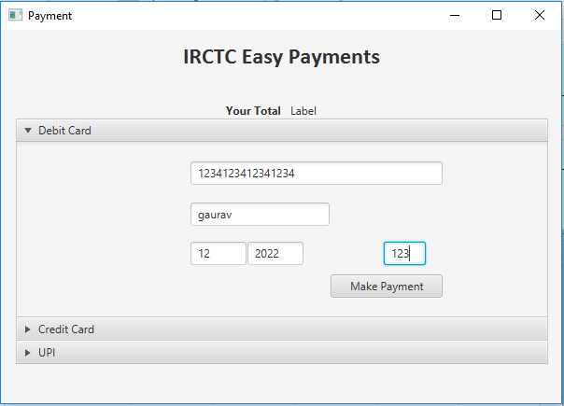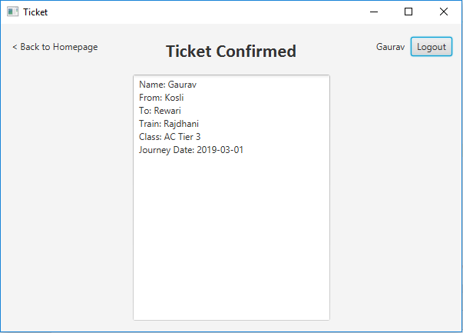

**Figure 5:**